Week 5 Homework
Stacks and Queues
By Lauren Geislinger
09/26/2020

First, I watched both videos for instructions. Here is what my original code from the in-class assignment looked like before alterations. I removed the comments after taking the screenshot:

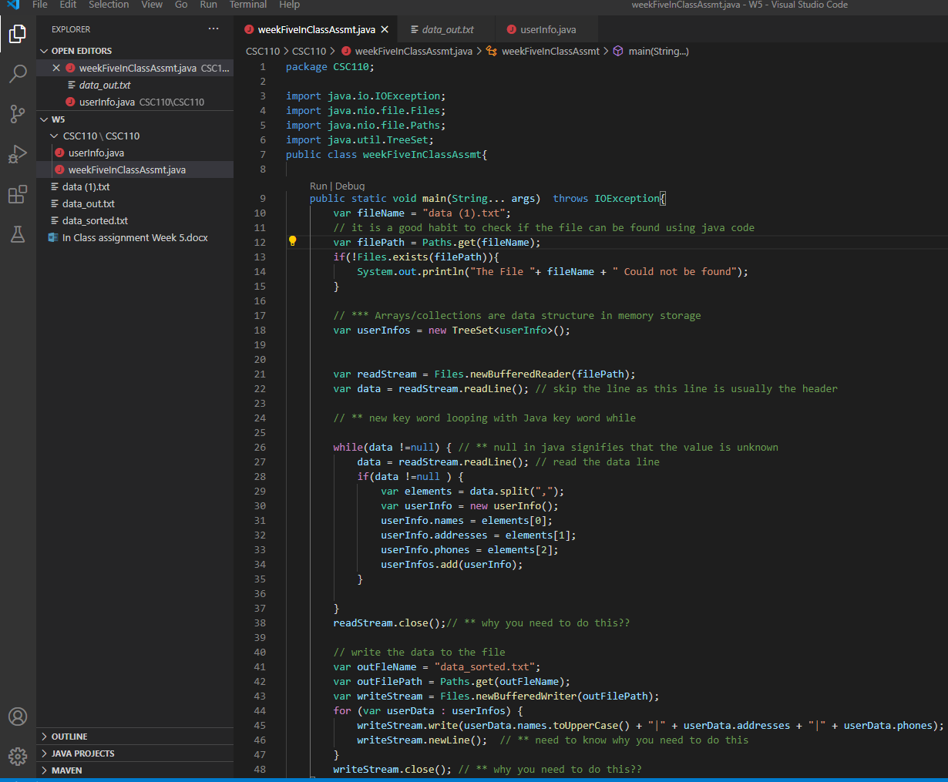

For the first part of the homework, I changed my userInfos data structure from a TreeSet to a Stack. The method needed to be changed as well, so the userInfo Variable and all elements can get pushed instead of added.

I made an error when printing results, I forgot that I would not be able to just use %userInfos as show in the screenshot. I fixed this by doing “%s “instead.

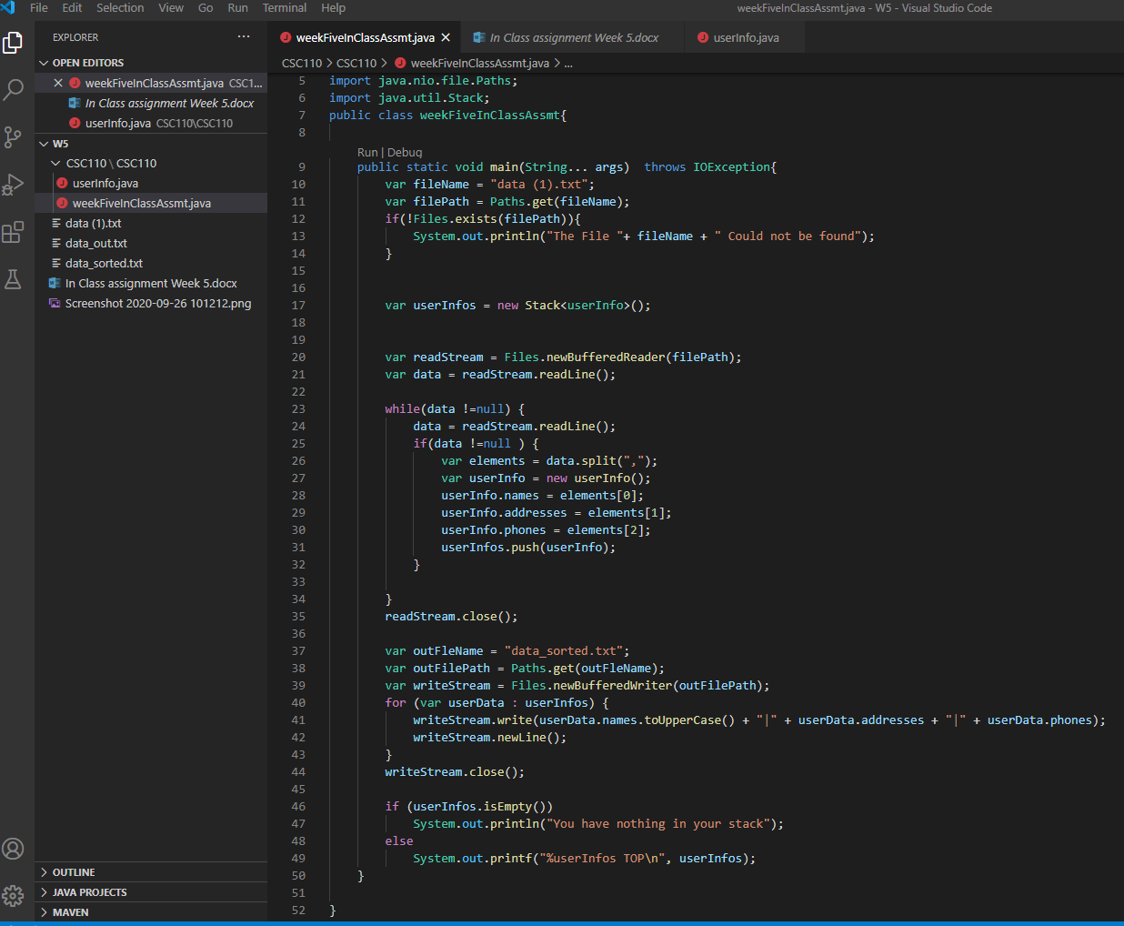

Next I did queue, I used PriorityQueue and the offer method, followed by the print examples shown in the video.
